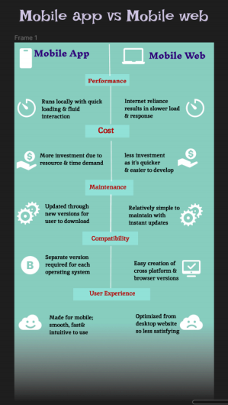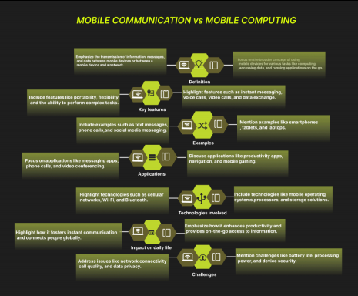**EXPERIMENT-13 Design an infographic in Figma comparing mobile communication and mobile computing.**